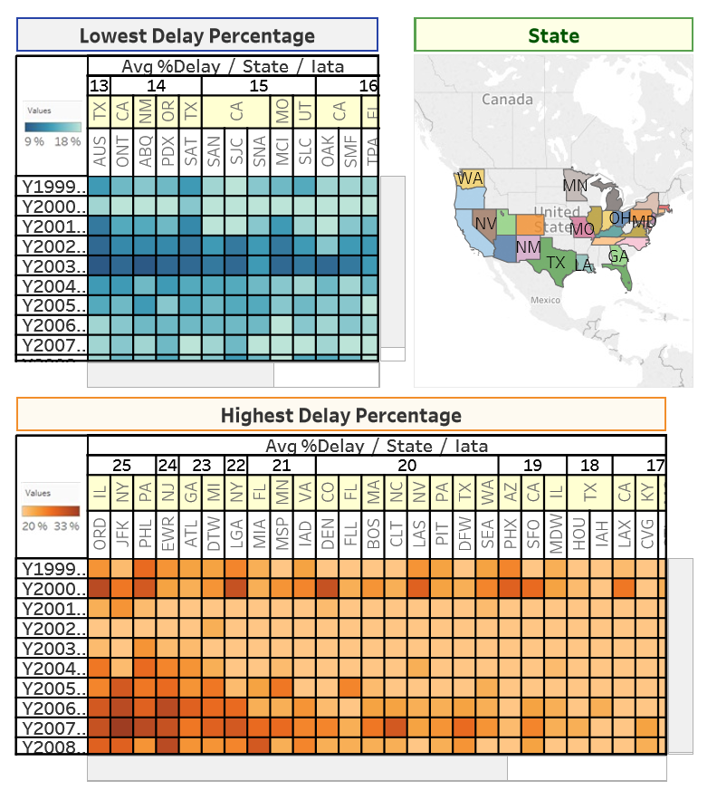

**Figure 3.1.1: Airports Performance**

**Purpose:** Present a heatmap visualisation representing the performance of airports from each state of the United States by its percentage of flights being delayed, showing data ranging from 1999 to 2008.

**Lowest Delay Percentage Heatmap**: Relative performance in the number of flights delayed, between 9% to 18%, is identified as different tones of green, with a darker tone indicating a lower percentage of delay and lighter tones indicating a higher percentage of delays.

**Highest Delay Percentage Heatmap**: Similarly, the relative performance in percentage of delays is identified using different tones, this time representing the range between 20% and 33% and with the colour orange. Lighter tones show a lower percentage of delays and darker tones indicating higher percentage of delays.

**Airport in State of USA Map:**

The map shows every state of the US that possesses at least one airport and differentiates these states using different colours. Hovering the mouse over any one of these states will interactively highlight the same state column(s) (if found) on each heatmap. Conversely hovering the mouse over any state of any of the heatmaps will highlight exclusively that state on the map.

Also, highlighting a single airport of any of the heatmaps will highlight the same airport column in the other heatmap (if found) as well as highlight the state that airport belonged to on the map.